FIT3039/3040 - Assignment 1 - Project Plan

# 

# Table of Contents

Table of Contents 1

Overview & Objectives 2

Project Overview 2

Project Length 2

Style & Aesthetics 2

Genres 3

Narrative Overview 3

Core Mechanics & Concepts 4

Sources of Inspiration 5

Target Audience 6

Project Scope 6

Delivery Platform 7

Group Member Roles 7

Development Software 8

Programming Tools 8

3D Modelling & Texturing tools 8

Project Management and Communication 9

Testing Methods & Evaluation 10

How Testing Will Be Conducted 10

Who Will Playtest 10

Testing Plan 10

Milestones & Feedback 11

Semester 1 11

Semester 2 13

# 

# Overview & Objectives

## Project Overview

Our project will be a fast-paced action movement shooter game set in an alternative reality version of earth from the late 1800s where technology has advanced at a much greater rate.

Recently however a large percentage of the population seems to have fallen into some kind of insanity with more and more people falling victim to this condition with each day that passes. You play as Dr Edward who is a psychologist who has been tasked with trying to find the cause of this insanity plague so that it can be stopped once and for all. To do this, you have been given access to patient zero of the insanity plague to use a machine he inherited from his grandfather which allows the user to enter the minds of others. Each level will take place inside of one of patient zero’s memories looking back towards the day they first fell victim to their insanity, these aren't just ordinary memories however, they have been twisted by whatever or whoever is behind the insanity plague in an effort to prevent you from finding the source and reaching them. The goal of each level will be to find the associated memory fragment which will help the player to uncover more and more of what happened to cause this nightmare. Within each level however the player will gain access to a limited time ability that is only available within that memory and will help the player to fight back against the hordes of hostile enemies attempting to stop them. Additionally the player will have access to a global mechanic available to them in all aspects of the game called Frenzy. Frenzy gives the player a permanent movement speed increase of up to 100% for killing enemies within each level, they will need to be careful however because taking damage causes the player to lose some of their Frenzy, slowing down their progress.

## Project Length

The project is aimed to be a 2 Semester project, finishing at the end of Semester 1 2024. One group member (Shyam) will be leaving at the end of the current semester (Semester 2 2023).

## Style & Aesthetics

The graphical style of our game will be focused around simple low poly models similar to games such as [Deep Rock Galactic](https://store.steampowered.com/app/548430/Deep_Rock_Galactic/), with bright and contrasting textures and exaggerated environments where things may not always make sense. This should help to give our game the feeling of being inside of someone else's mind as they fall deeper and deeper into insanity and also create a unique identity.

The audio aesthetic will be an energizing, high-tempo beat that compels the player to play the game at a fast pace. We will aim for a rock-esque soundtrack, similar to that from [Roboquest](https://store.steampowered.com/app/692890/Roboquest/).

## Genres

The narrative genre for our game will lean towards a psychological horror/mystery theme which will contrast the fast paced gameplay to create a unique experience.

The gameplay genre will be Action FPS with a primary focus on player movement to support exhilarating parkour and fast-paced, challenging combat.

## Narrative Overview

### Story Prologue

Our game will be set on earth in the late 1800s in an alternate universe where technology has progressed much faster then on our world. In this alternative dimension, a recent global problem has arisen known as the insanity plague. The insanity plague has caused a large portion of the population to fall into a deep insanity causing them to become unable to control themselves and if nothing is done to stop it, it will almost certainly result in [societal](https://en.wikipedia.org/wiki/Joker_(2019_film)) collapse.

### Protagonist’s Role

Our protagonist and player character will be Dr Edward who is a psychologist investigating the insanity plague but has been unable to make any real progress when it comes to solving the problem until one day he remembers about a machine he inherited from his grandfather when he was just a boy which allowed the user to enter the minds of others. Dr Edward reveals the machine to the governments of the world who provide him with patient zero of the insanity plague in order to test the machine on, Dr Edward is reluctant to use the machine due to it being untested and could be risky for both the user and the patient however with time running out, decides to use the machine to enter the mind of patient zero.

### Tutorial Level

Dr Edward will have to make his way through the facility which is being overrun with victims of the insanity plague who are all trying to attack him. Guided by his AI assistant, Sparks, Dr Edward (the player) must learn how to defend himself and make his way through the partially destroyed facility in order to reach the room where patient zero is being held (and teach the player the mechanics of the game) in order to use the machine to enter their mind.

### Hub Area

Once inside the mind of patient zero, Dr Edward will be placed in a small corridor that leads to a large hexagonal shaped room with a table in the center with what loops like one-sixth of a puzzle placed on it. On each of the surrounding walls there is a door. Each of which seem to lead to a completely different location (level selection). 4 of the 5 doors are covered at first in some strange black goo which is preventing them from being opened and so Dr Edward decides to enter the only room which is not currently locked.

### Main Levels

Upon entering a memory, Dr Edward finds himself inside a twisted world made up from parts of one of patient zero’s memories. Sparks points out a strange relic to Dr Edward and so he examines the artifact for a moment before he is attacked by a horde of strange creatures and so decides to pick up the relic and use it alongside the rest of his tools in order to fight his way through the horde. After the creatures are all defeated, Dr Edward progresses through the landscape, guided by sparks who can detect something of great importance within this memory. As they progress through the memory, Dr Edward is attacked by more creatures and navigates through treacherous grounds until eventually reaching what almost seems like a temple. Upon entering he is attacked by a massive creature that he must use all the tools at his disposal to take down. After defeating the creature it is revealed on a pedestal a shard that appears to be another piece of the puzzle from the hexagonal room (Hub Area). When Dr Edward makes contact with the shard the memory begins to become clear and Dr Edward now stands within a much more familiar environment. This clarity does not last long however as Dr Edward is quickly pulled back into that hexagonal room where he places the memory fragment on the table and the black goo blocking him recedes from one of the other doors unlocking it (level progression).

## Core Mechanics & Concepts

Our game will have two core mechanics, the first of which is called Frenzy. Frenzy is a stacking ability where the player will gain a batch of stacks (10 stacks) every time they kill an enemy, and each stack will increase the player’s movement speed by 1% per stack. Frenzy will be able to stack up to 100 times, and will begin to decay after not getting a kill for 10 seconds, at an estimated rate of 1 stack per second. Frenzy can also be lost in batches (5 stacks) whenever the player takes damage .

An additional component to the frenzy mechanic is that it can supercharge the player’s ability. When the player has 80 or more stacks of frenzy, their next ability use will be supercharged. This will transform their ability into a more powerful version of itself, and will drain 20 stacks of frenzy to do this. For example ‘Blood Punch’ when supercharged will gain the ability to stun afflicted enemies for a short duration.

The second of our core mechanics changes with each level but will always be bound to the same keybind and is the player’s Active Ability. This ability does different things in each level and will only ever perform that ability in the specific level. For example, our first level concept is currently called the “Meat Level” and is set inside a giant body where the player's Active Ability is currently called the “Blood Punch” which will allow the player to launch themselves in a given direction dealing damage and knocking back any enemy they collide with.

# Sources of Inspiration

## Doom Eternal

[Steam Link](https://store.steampowered.com/app/782330/DOOM_Eternal/)

Doom Eternal is a first-person movement shooter game developed by id Software and published by Bethesda Softworks. Doom Eternal’s gameplay loop revolves around short stints of fast-paced intense combat broken up by simple platforming puzzles and sometimes ending each level with a boss fight. We intend on making our game share a similar gameplay loop to Doom Eternal having short stints of high octane combat broken up by small platforming sections and also to have no passive out of combat health regeneration and instead having the enemies killed drop health orbs in order to encourage a more aggressive playstyle.

## Deep Rock Galactic

[Steam Link](https://store.steampowered.com/app/548430/Deep_Rock_Galactic/)

Deep Rock Galactic is a low poly mining game set in a procedurally generated cave system where the player must complete a given objective set before they are able to extract. DRG uses low poly models with simple yet vibrant textures to bring the world to life. Our game intends to partially replicate this aesthetic style, also using low poly models and simple vibrant textures to immerse the player in the world our game is trying to create.

## Overwatch 2

[Blizzard Link](https://overwatch.blizzard.com/en-us/)

Overwatch 2 is a Class based FPS multiplayer game where 2 teams of 5 players each make a team composition from the game's roster of heroes, including tanks, dps and supports, and then battle against another team in order to either attack or defend an objective. Our game aims to take the idea of having specific abilities which change the way you play the game and currently takes inspiration from [Doomfist](https://overwatch.fandom.com/wiki/Doomfist)’s Rocket punch ability which allows the player to charge up a punch before launching themselves forward, damaging and knocking back any enemy they collide with.

## Roboquest

[Steam Link](https://store.steampowered.com/app/692890/Roboquest/)

Roboquest is an FPS roguelike game where the player controls a guardian robot as they traverse a post apocalyptic wasteland fighting off waves of robots that get progressively more and more threatening. Roboquest has a high tempo OST that fits well with its fast-paced gameplay. Our game aims to take inspiration from this OST and create a catchy, energizing rock-esque beat to compliment our games high octane gameplay.

# Target Audience

The primary target audience for our game is young adults ages 15 and up who enjoy fantasy RPG and dark theme horror games. The game will be aimed specifically at people who are PC gamers and play games like Doom Eternal regularly, as they will be accustomed to the challenge and find the most enjoyment out of these types of games. However, the game will still have the assistance available to support less experienced players to play it and enjoy it. The game will primarily target Australian gamers as the developers are based in Australia, however it will be available worldwide via a globally-accessible online storefront.

# Project Scope

For our project we aim to create approximately 5 total levels, a general hub area where the player can select a level from, 1 boss fight for the end of the game and 1 tutorial level at the beginning to teach the player the basics of the game. The game will also need work done for the in-game HUD, pause menu, main menu, settings menu and credits. Our goal is to have the central hub, tutorial level, 2 or 3 “main level mechanics” as well as all UI/UX components completed and the first of the 5 main story levels started by the end of the first semester of the project (Semester 2 2023).

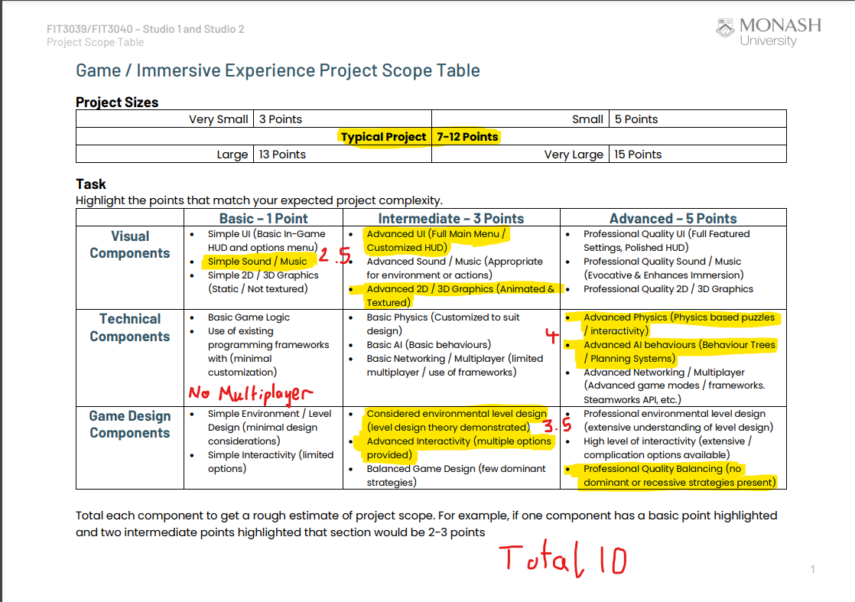

# Delivery Platform

Currently the only planned delivery platform for our game will be PC and distributed via online game storefront itch.io. This is primarily due to the approval process for games to be ported to consoles being a time consuming and potentially expensive process which we have decided is not justifiable for this project specifically. Regarding input systems, the pacing of our game is very fast and will require rapid and precise movement from the player in order to play the game effectively. For this reason mouse and keyboard is the preferred input system for this kind of game as it does not have the sensitivity and precision restrictions that come with controllers. That being said, the game will aim to include controller support for PC users so that those who prefer to play with a controller will still be able to enjoy our game.

# Group Member Roles

“Lead” role(s) are **bolded**.

| **Name** | **Role(s)** |
| --- | --- |
|  | **Programmer - Player Mechanics**, World Mechanics, **UI/UX** **Designer** |
|  | **Project Manager**, **Programmer - Enemy Mechanics** & World Mechanics |
|  | **3D Modelling/Texturing - Entities & World Objects**, **Animations** |
|  | **3D Modelling/Texturing - Game Maps**, Animations, **Narrative Designer** |

# 

# Development Software

## Programming Tools

### Unreal Engine 5

Our game engine of choice is Unreal Engine 5, which will be the basis of the development of our project. Our project is a FPS game and based on our research UE5 is considered the best choice for programming and designing FPS games as it originally specialized in it. Our previous choice was Unity, which like UE5 can create all kinds of games, but generally specializes in 2d games. For this reason we have decided to use UE5, specifically, we’re starting with version 5.2.1 but will keep the project up-to-date with the latest stable release.

### Git

Git is the tool for us to store and share the project with our group, and work collaboratively. Git contains features such as branching to facilitate real-time collaboration, and automatic version control which keeps a retrievable version history of all files. We are using a git repository under the Monash Information Technology Gitlab (<https://git.infotech.monash.edu/fit3039-group/gameproject>).

### Jetbrains Rider

Jetbrains Rider is the most suitable tool for us to do the programming work for our project which is based on Unreal Engine 5. This is because Rider is an advanced modern Integrated Development Environment which contains many features to support an efficient workflow of real-time development and ease of use specifically for UE5. It is also what all group members are most comfortable with, due to being taught and using it in previous units.

### Microsoft Visual Studio

Microsoft Visual Studio is a necessary component to use the Unreal Engine 5 software, and so it is installed but will not be used for programming work, which will be done via Jetbrains Rider as previously mentioned. Both Visual Studio and Rider support the C++ language.

## 3D Modelling & Texturing tools

### Autodesk Maya 2023

Autodesk Maya is a 3D modeling software that will be used to make the models for our project. Maya is not only industry standard, but very accessible, easy to use, and supports exporting in the file formats we need for our project and other software.

### Adobe Substance Painter

Adobe Substance Painter is a powerful tool used to texture and paint 3D models. It allows us to make complex and realistic textures for models which make our environment more believable and help the player get immersed in the game world.

## Project Management and Communication

### Trello

Trello is a project management web-based software that we will use to track specific tasks and goals of our project that need to be completed by specific due dates and times. It will help us to stay on top of our overall plan and ensure we are completing essential parts of the project when they are needed, without forgetting about other tasks.

### Discord

Discord is a voice and text chat communication software, which will be used to maintain contact within the group, to keep each other informed of any and all information, and to host weekly online group meetings to check in on individuals’ progress towards the completion of the assignment.

### Google Drive

Google Drive allows us to easily share ideas and files with one another. By uploading files they instantly become available for everyone else to download, making file transfer quick and easy. Google Drive also automatically maintains a version history for any files uploaded to it, meaning we have automatic backups and versioning for any files shared outside of the git repository.

### Google Docs

We will primarily use Google Docs to work on our project plan and design documents. It is a web-based document editing software that allows us all to collaborate and edit documents together in real time. This will significantly improve our workflow by reducing the time delays that would be spent sending documents back and forth. It supports importing and exporting to and from other common file types such as word documents, pdf files, and anything else we need.

# Testing Methods & Evaluation

## How Testing Will Be Conducted

The main goals of our testing and evaluation is to test the accessibility, stability and balance of our mechanics, UI design and levels. We will record the testing process and discuss the game experience with our playtesters, and try to fix any bugs related to the stability, then adjust the parts that playtesters are confused or unhappy with after each testing.

We will check the recording of the testing process and if playtesters are struggling with frenzy mechanics or combats, we may simplify the combat or reduce the enemies’ health in levels. If playtesters are confused with our UI, we will make it more clear and simplified. If playtesters find our level is unbalanced, we will change the enemy and loot setting of levels.

## Who Will Playtest

Our primary playtesters will be our classmates from FIT3039 and FIT3040, who will playtest our game 3 times each semester in class.

Our ideal playtesters would be young adults who regularly play fast-paced action FPS games as they are the target audience who we are primarily designing the game for, and so will be able to give the most relevant feedback. We note that this does not mean that those outside of this target demographic will be less useful playtesters - it is just as important to consider others’ opinions and feedback.

## Testing Plan

Primary points of feedback which we aim to gather will revolve around 2 major areas. Firstly, we want to gather information about as many bugs as playtesters can find. We primarily want information about how to replicate these bugs in order to trace them back to their causes and (hopefully) remove them from the game. Secondly, we want to gather feedback about player enjoyment in our game. The main areas of concern as far as enjoyment goes are as follows:

1. Are the mechanics fun to use? If not, what could make them more fun?
2. Is the game's difficulty too hard or easy? If so, what about the game made it too hard/easy?
3. Are the game’s objectives clear to the player? If not, how could the player be better guided towards game objectives?

We plan to gather this feedback through the use of a google form which will be provided via a link to each playtester.

## Milestones & Feedback

## Semester 1

### Week 6 - Playtest 1

##### **Goals of test:**

* UI accessibility
* Frenzy Mechanic
* Basic Enemy Functionality
* Punch Ability (if possible)
* Level layout
* Get player’s feedback of game experience

##### **Features required to be implemented prior to test:**

* Tutorial mostly fleshed out
* Basic enemy AI implemented
* Healing Mechanic done
* 1-3 “level mechanics” programmed
* Interactables graphic/texturing done

### Week 9 - Playtest 2

##### **Goals of test:**

* More Advanced Enemy Functionality
* Improved / Added Textures
* Another unique ability
* Level layouts for tutorial, hub area, and level 1
* Get player’s feedback of game experience

##### **Features required to be implemented prior to test:**

* Tutorial fully fleshed out
* More complex AI implemented
* Level transition
* 1-3 “level mechanics” implemented, fully working and feeling good to use
* Interactables graphic/texturing done for the tutorial
* Implementation of player feedback from week 6 playtest

### Week 12 - Playtest 3

##### **Goals of test:**

* Implementation of player feedback from week 9 test
* More Advanced Enemy Functionality
* Improved / Added Textures
* Another unique ability
* Level layouts for tutorial, hub area, and level 1
* Get player’s feedback of game experience

##### **Features required to be implemented prior to test:**

* Hub fully fleshed out
* Level 1 basic blockout completed
* 1-3 Unique enemies implemented with different behaviors
* 3-5 Unique level mechanics implemented
* Interactables graphic/texturing done for the tutorial
* Implementation of player feedback from week 9 test

## Semester 2

### Week 6 - Playtest 1

##### **Goals of test:**

* Testing Levels 2 & 3
* Searching for bugs and issues that require attention
* Gather feedback on player enjoyment

##### **Features required to be implemented prior to test:**

* 2-3 Levels implemented
* Implementation of feedback from previous playtests
* General polish and refinement

### Week 9 - Playtest 2

##### **Goals of test:**

* Testing Levels 3 & 4
* Searching for bugs and issues that require attention
* Gather feedback on player enjoyment

##### **Features required to be implemented prior to test:**

* 3-4 Levels implemented
* Implementation of feedback from previous playtests
* General polish and refinement
* Improved and refined textures

### Week 12 - Playtest 3

##### **Goals of test:**

* Testing Level 5 and boss fight mechanics
* Searching for bugs and issues that require attention
* Gather feedback on player enjoyment and general game balance

##### **Features required to be implemented prior to test:**

* All 5 Levels implemented, Boss fight in 5th level
* Implementation of feedback from previous playtests
* General polish and refinement
* Completed Menu and Game Logic